A: Data Profiling

# Part 1: Overview

One critical activity of data warehousing is the ability to profile your organization’s data and business processes. Data profiling is the activity of learning about the characteristics, capabilities, and quality of your data and metadata (schema). Getting intimate with your data in an important step in building the data warehouse because you must understand what you have to work with before you can leverage it as part of your data warehouse solution. This assignment will help you discover how to understand your organization’s data so that you can figure out how to properly build a data warehouse around it.

## Goals

Specifically the goals are to:

* Get you familiar with how to use the tools provided in the course.
* Help you understand how to profile data – reading unknown database schemas / data and deducing intent behind table designs and data.
* Get you comfortable writing SQL SELECT queries against a relational database, as a means to understand the capabilities of the data and metadata that you have.

## Effort

This assignment should be done individually. The work you complete should represent your own ability.

## Technical Requirements

To complete this assignment you will need the following:

* Microsoft SQL Server Management Studio.
* Access to the **ist-cs-dw1.ad.syr.edu** Microsoft SQL Server. The connection procedure is explained in another document.

## The Northwind Traders Case Study

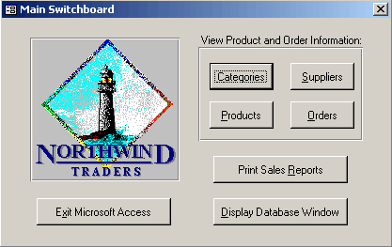Northwind traders is a fictitious importer and exporter of specialty foods from around the world. It was created by Microsoft as a sample operational database to use with their database products, such as Microsoft Access and SQL Server.

We’ll use this database as a case study for building a data warehouse. You will use this same database throughout each of your assignments in this course and will get very intimate with the data and table design.

## The Northwind Data Model

Below is a screen shot of the internal model for the Northwind Traders database. Use this diagram as a reference for understanding the structure of the Northwind data and building your data warehouse.

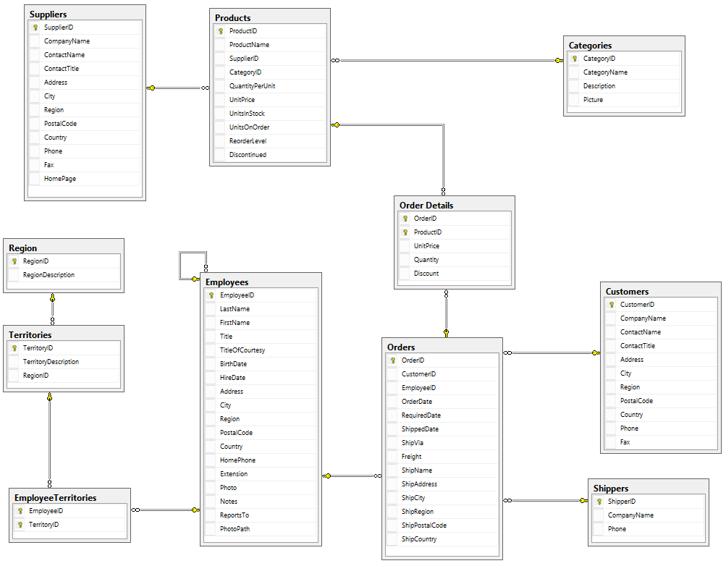

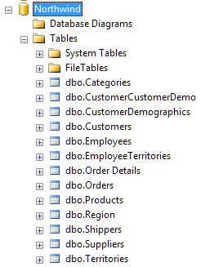When you open the **Northwind** database in SQL Server Management Studio’s object explorer, you will see the following tables which comprise the database.

Some of these tables such as the **Customer\*** tables represent master data. They exist to store information about a key business entity, in this example *customers*.

Other tables, like **Orders** represent business activities. These are transactions, events or actions. From a data warehouse perspective, all source data falls into one of these two categories.

It should be noted that the boundary of what are master data or activities does not always align with the database tables. You must look at the business processes themselves and how data flows through the organization. The tables are just an implementation and like any implementation they are at the discretion of the database designer.

Of course in this class we cannot ask someone who works at Northwind Traders about customers or orders. We can only make assumptions about how they would use the data, and for that reason we will rely heavily on the existing database schema.

## Assignment Structure

All technical assignments in this course are structured in the same manner. Their purpose is to give you hands-on experience “doing” data warehousing; allowing you to put into practice the concepts you learned through the class sessions. You will learn quite a bit as you work through these assignments. This is by design. Every assignments begins with an overview section which explains the activity, its goals, and requirements.

The second part of the assignment will walk you through the process of completing the activity. In this particular assignment it’s profiling data from the Northwind Traders database.

The third part of the assignment, you must complete on your own. It is expected you will take what you learned from your studies, class sessions, and your experiences with parts 1 and 2, then apply them towards the problems you face in the 3rd part.

At the end of the assignment it is stated what you should hand in as a deliverable to demonstrate you completed the work to satisfaction.

# Part 2: Walk-Through

In this part we will walk you through the process of data profiling. We will profile two types of sources, a master data source, and a business process.

## First Step: Is That Master Data or A Business Process?

In our walk through, our master data will be Employees and our business process will be the assignment of sales territories to the employee.

How do you know which source is master data and which is a business process? The trick is to think of your data at the conceptual model level:

Employee

Territory

🡪 Assigned To 🡪 1/M

1/M 🡨 Assigned To 🡨

* An **Employee** is *assigned to* 1 or more **Territories**
* A **Territory** is *assigned to* 1 or more **Employees**

In this example Employee and Territory are master data. They represent categorical business data. The Many-To-Many relationship between them is a business process representing who gets assigned to which territory.

In the Kimball method of data warehousing your master data become ***dimensions*** and the business processes, events or transactions become ***fact tables***. Honestly, that a gross over simplification, but for now it works.

## Next: Understanding your data at its atomic level.

Now that you know which are master and which are business processes. It’s time to understand the following:

* What are the business or natural keys? We’re not interested in the primary key, which is internal to the RDMBS implementation. We’re looking for what makes each entity unique from the business user’s vantage point. There should always be a natural key for master data, but there might not be one for business processes.
* What does “one row” of data mean? The answer to this question often reveals itself when you discover the business key or identify the business process.

The easiest way to figure this out is by using the select statement. Observe:  
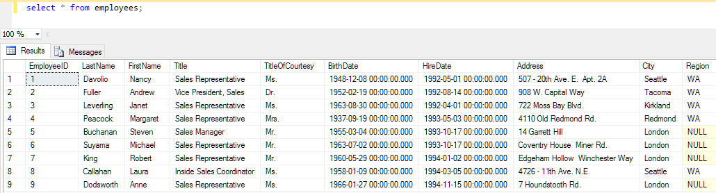

If you want to try it for yourself, open a new query window in the Northwind database by pressing **CTRL+N**, then type the select statement and press the **!Execute** button in the toolbar.

It appears as if there’s one row for each employee. That stands to reason, but to be honest it’s not always that simple.

What about the business key? What is used to uniquely identify the employee? Normally this would be social-security number or tax payer ID number as each row would have a unique value. With this data it’s not clear. You might think of using name:

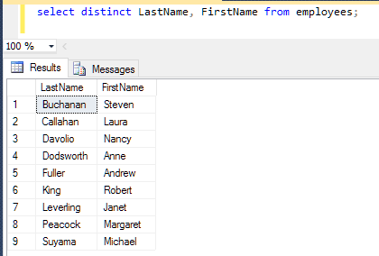It seems to work as there are still 9 rows so we didn’t lose an employee.

It’s not a good business key because there could be two employees with the same name. In this case there isn’t but we should always think *beyond the data* when we’re profiling.

In this case we have no choice but to use the Primary key **EmployeeID**.

## Finally: Understanding the characteristics of your data

In addition to knowing what one row means, you might need to discover other characteristics of your data. These are commonly dictated by the business requirements. It’s crucial to understand “what you have” so that when it is delivered to the data warehouse you can determine if the data are still accurate. We only want quality data in our data warehouse.

Here are some sample queries, which might be asked as part of a functional business requirement and the SQL statements which satisfy them.

What are the different job titles for each employee?

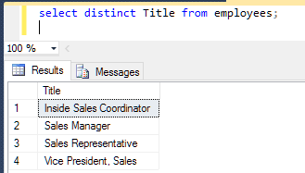There are 4 distinct job titles for 9 employees. That’s a decent category, as possibility for drill-down in our analytics as well see in future assignments.

Example: How many sales people per territory?

From the screenshot we now know there is only 1 territory with more than one employee assigned: **New York**.

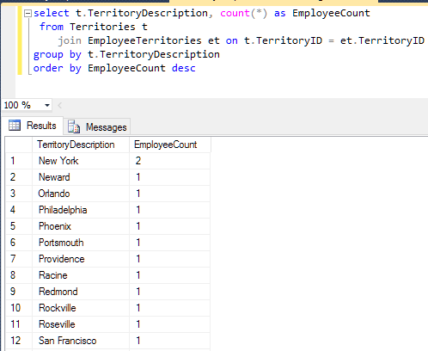Let’s take a moment to break down this SQL statement as writing queries like this is common practice in data profiling.

We are joining the **Territories** table to the **EmployeeTerritories** table so we can get a count (**count(*)**) of employees for each **TerritoryDescription** (that’s the **group by**). The **t** and **et** are table aliases. These are needed since both tables have a column called Territory ID.

We **order by** **EmployeeCount** to see the Territories with the most employees first.

# Part 3: On your own

Profile the following table in the Northwind Traders Database. The first two have been done for you in the previous part.

|  |  |  |  |  |
| --- | --- | --- | --- | --- |
| **Table** | **Type** | **Row Count** | **Business Key** | **One Row Is** |
| Employees | Master Data | 9 | None (PK used) | An Employee |
| EmployeeTerritories | Business Process | 49 | None (PK’s used) | An Employee assigned to a territory. |
| Customers |  |  |  |  |
| Suppliers |  |  |  |  |
| Products |  |  |  |  |
| Shipments (of Orders) |  |  |  |  |
| Details (of an Order) |  |  |  |  |

Write SQL Queries to answer the following questions which might be associated with functional business requirements in a data warehouse. For each of the following provide a screen shot of the SQL query, its output, and make sure your name or netid appears in the screenshot.

1. List the customer contact names and titles sorted by company name.
2. Factoring in discounts, what is total amount of product sold?
3. Provide a list of product category names with counts of products in each category.
4. Select a specific customer and display that customer’s orders with total amount of product sold for each order.
5. Select a specific employee and each order, how it was shipped (shipvia) company who shipped it, and the total number of days elapsed from order date to shipped date.

# Turning it in:

Please turn in a word document with your name, netid, and date at the top. Copy and paste your completed part 3. Be sure you include screenshots as directed.

Do not submit a copy of this assignment file. I only need the part 3.